Computer Concepts

Unscramble the following terms relating to Types of Computers.

rspue pcremtuo _______________ femaranim _______________

nlpresoa pcetoumr _______________

Matching (Types of Computers)

A. Mainframe B. Personal Computer C. Super Computer

____ 1. This type of computer is usually owned by large businesses and government agencies and handles a large amount of data such as customer billing, payroll preparation, and inventory management.

____2. This type of computer handles large scale applications in medicine, aerospace, auto designs, online banking, and weather forecasting and is the fastest/most powerful/most expensive computer.

____3. This type of computer is found in schools, homes, or offices and is used daily by most everyone.

Unscramble the following Components of a Computer System.

dehrwar _______________ sgpincesor _______________

oeatwrsf _______________ rdrotmeabho _______________

puint _______________ pittuuo _______________

aatd _______________

Matching (7 Components of Computer)

A. Output device D. Input device G. Motherboard

B. Data E. Software H. Hardware

C. Processing F. Operating System Software I. Application Software

____1. Tangible, physical component of the computer

____2. Devices used to show the result of the data entered into the computer.

____3. Software installed that performs a specific task.

____4. Taking the data entered and changing it into a useful output format.

____5. An intangible component that is installed on your computer.

____6. Devices used to enter data into a computer.

____7. Words, numbers, sounds and graphics that describe people, events, things and ideas

____8. This is the main electronic component of the computer.

____9. Software installed that controls your entire computer.

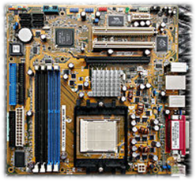 **10. The image at the left represents a _____________________ and is the main electronic component of the computer. It represents a (type, component) of a computer.**

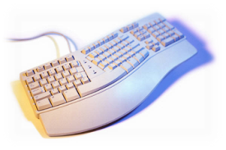 **11. This is a keyboard and is the most common type of _________ device.**

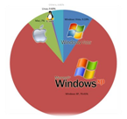**12. Another component of the computer systems that is intangible and controls basic input and output, and manages storage and computer protection is ____________________.**

**C:\Documents and Settings\kbragg\Local Settings\Temporary Internet Files\Content.IE5\MH9DXP8M\MC900349609[1].wmf13. This hardware component takes the data entered and _______________ the data and modifies it into a useful output.**

**14. Represents words, 1234, and sounds and is an example of which component of the computer system? ____________________**