K.I.M Learning Strategy
Focus: Types of Memory
K  (K=Key Vocabulary Word)  Random Access Memory  (RAM) | I  (I=Informative/Definition) | M  (M=Memory Cue/Picture)  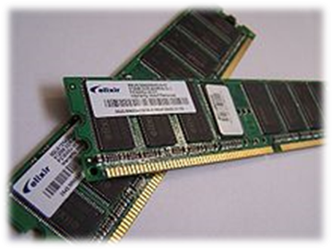
Use Word in Sentence:

K  (K=Key Vocabulary Word)  Read Only Memory  (ROM) | I  (I=Informative/Definition) | M  (M=Memory Cue/Picture)  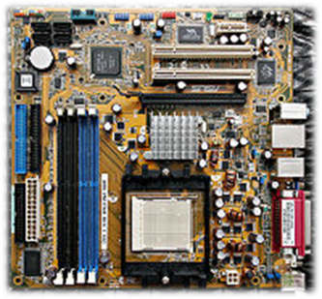
Use Word in Sentence:

