Multi-Family Garage Sale
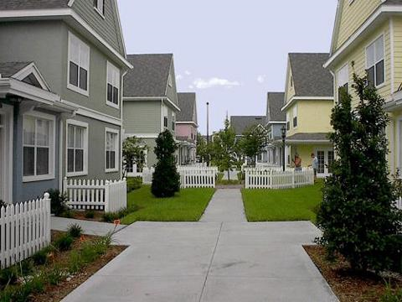

You can find toys, clothes, appliances, sporting equipement, furniture, art, books, etc.!
Everything is of the highest quality and in excellent condition!

Come by and make us an offer!

Saturday from 6 a.m. to noon

